✅ What is random_state?
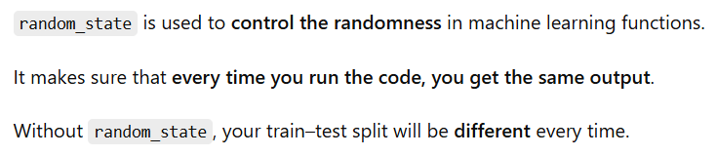
📌 Why do we need it?
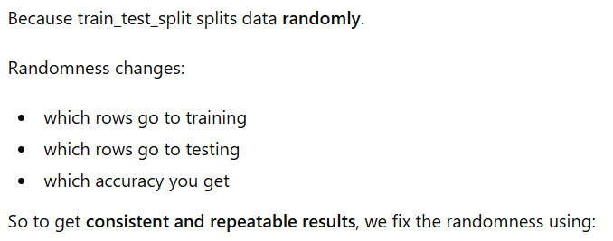
🎯 Very Easy Example
Suppose your dataset has 10 rows:
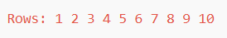
Case 1: Without random_state
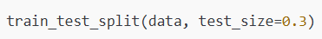

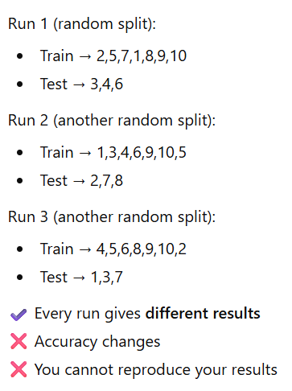

Case 2: With random_state
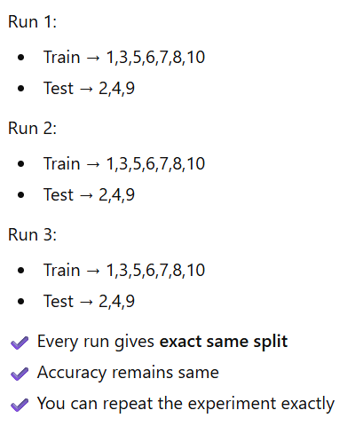
random_state acts like a "seed" that controls randomness → making results repeatable.

random_state=8 and random_state=12 are just two different seeds → both give fixed but different data splits.

